Allotment Hill, Leigh, Ibberton DT11 0EJ
Problem:
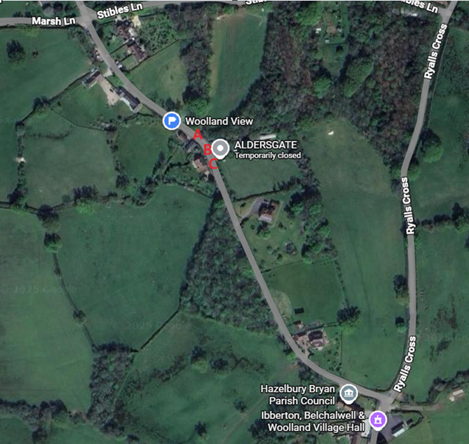
Very large vehicles travelling down / up Allotment Hill having difficult manoeuvring around the corner / pinch point that borders dangerously close to the barn belonging to Woolland View.

A width 3.00 m
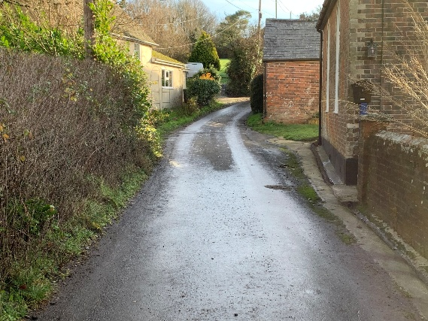 | 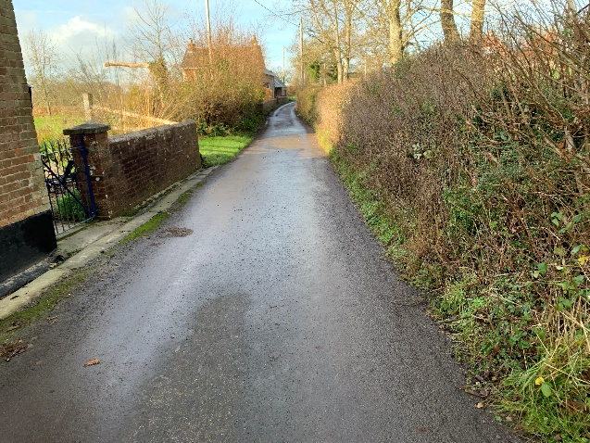
B Width 2.80m
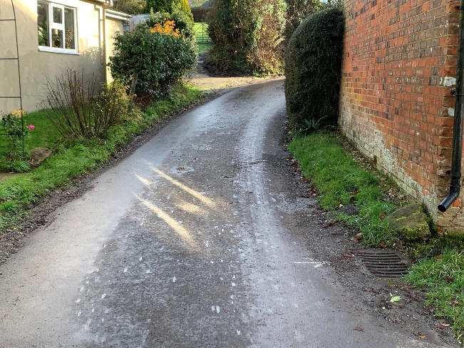 | 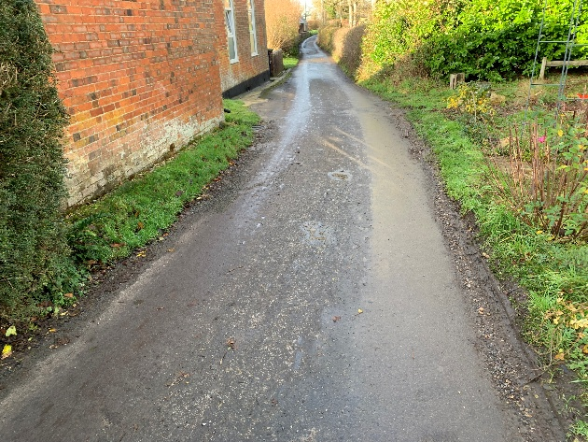
C with 3m
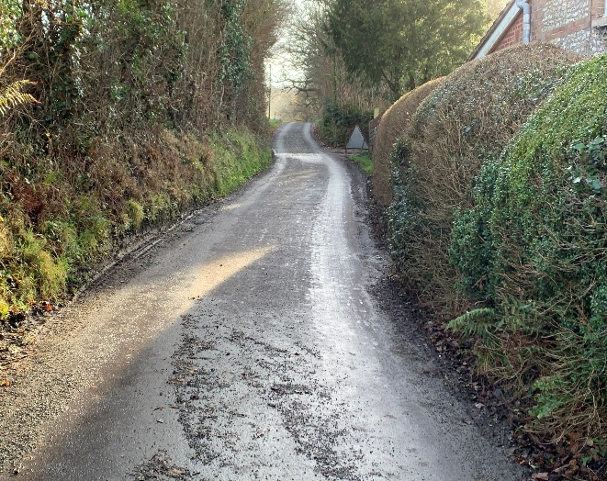 | 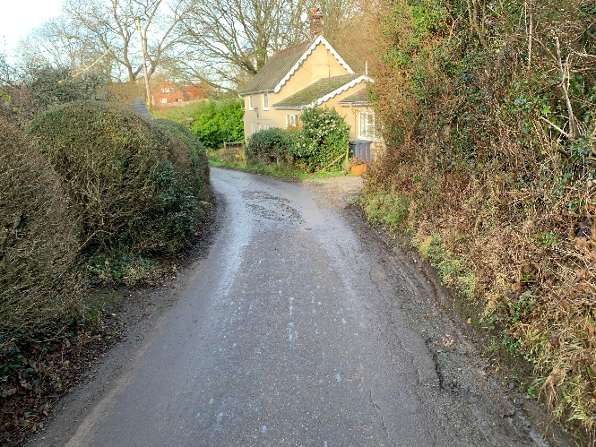

Possible Solution:
